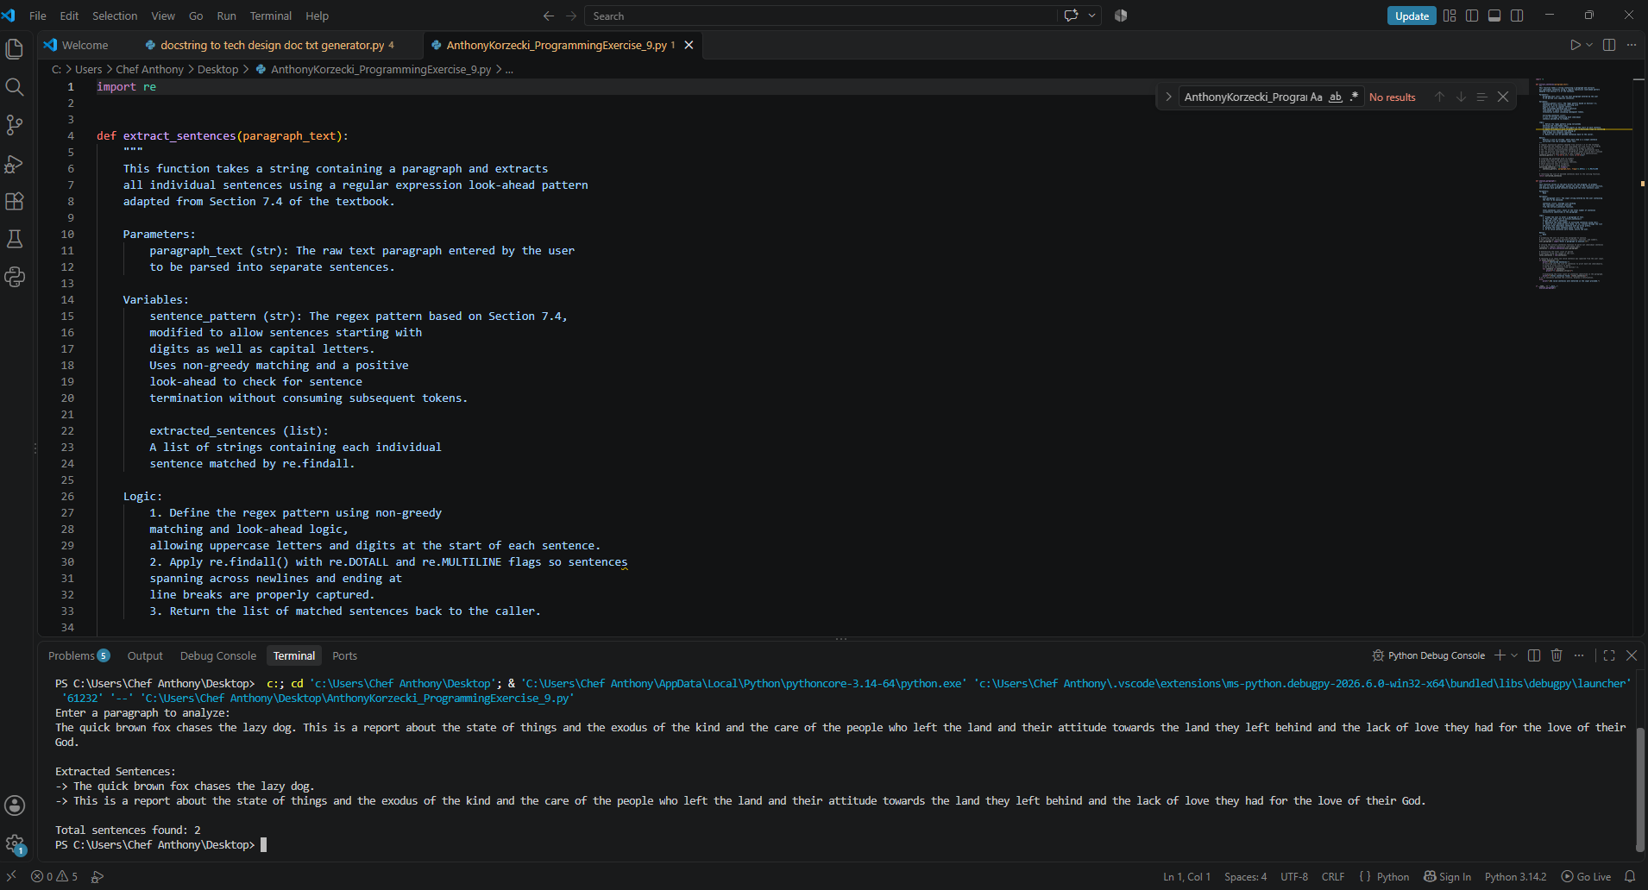

# Technical Design Document: AnthonyKorzecki_ProgrammingExercise_9

# Name: Anthony Korzecki
# Date: October 25, 2026
# Program Description: This program prompts the user for a paragraph, uses regular expressions with positive look-ahead assertions to parse out individual sentences—including those starting with numbers and displays each sentence along with the total count.

## Function: analyze_paragraph
This function serves as the main driver for the program. It prompts
the user to enter a paragraph, passes the text to the extraction function,
and displays each parsed sentence along with the total sentence count.

Parameters:
None

Variables:
user_paragraph (str): The input string entered by the user containing
the text to be analyzed.

sentences (list): Storage list holding
the individual sentences returned
from the extract_sentences function.

total_sentences (int): Count of the total number of sentences
successfully identified in the paragraph.

Logic:
1. Prompt the user to enter a paragraph of text.
2. Pass the input text to extract_sentences()
to get the list of sentences.
3. Determine the total number of extracted sentences using len().
4. Check if any sentences were found. If so, iterate through the list
and print each individual sentence with an arrow prefix.
5. Display the final sentence count to the user.
6. If no valid sentences were found, notify the user.

Return:
None

## Function: extract_sentences
This function takes a string containing a paragraph and extracts
all individual sentences using a regular expression look-ahead pattern
adapted from Section 7.4 of the textbook.

Parameters:
paragraph_text (str): The raw text paragraph entered by the user
to be parsed into separate sentences.

Variables:
sentence_pattern (str): The regex pattern based on Section 7.4,
modified to allow sentences starting with
digits as well as capital letters.
Uses non-greedy matching and a positive
look-ahead to check for sentence
termination without consuming subsequent tokens.

extracted_sentences (list):
A list of strings containing each individual
sentence matched by re.findall.

Logic:
1. Define the regex pattern using non-greedy
matching and look-ahead logic,
allowing uppercase letters and digits at the start of each sentence.
2. Apply re.findall() with re.DOTALL and re.MULTILINE flags so sentences
spanning across newlines and ending at
line breaks are properly captured.
3. Return the list of matched sentences back to the caller.

Return:
Returns a list of strings, where each item is a single sentence
extracted from the original input text.

#Link to your repository: https://github.com/akorzecki/COP2373-11162

